Meta Title:
Top- Rated Esthetician School in Houston, TX
Meta Description:
Image Academy's esthetician course combines theory with practice. It covers everything from the fundamentals of esthetics to facial treatments. Enroll Now!
Esthetician Page
https://imageacademy.org/esthetician/
esthetician | 201000 | 47
esthetician school | 74100 | 46
esthetician school near me | 22200 | 36
licensed esthetician | 2900 | 39
esthetician programs near me | 2400 | 30
esthetician certification | 1000 | 28

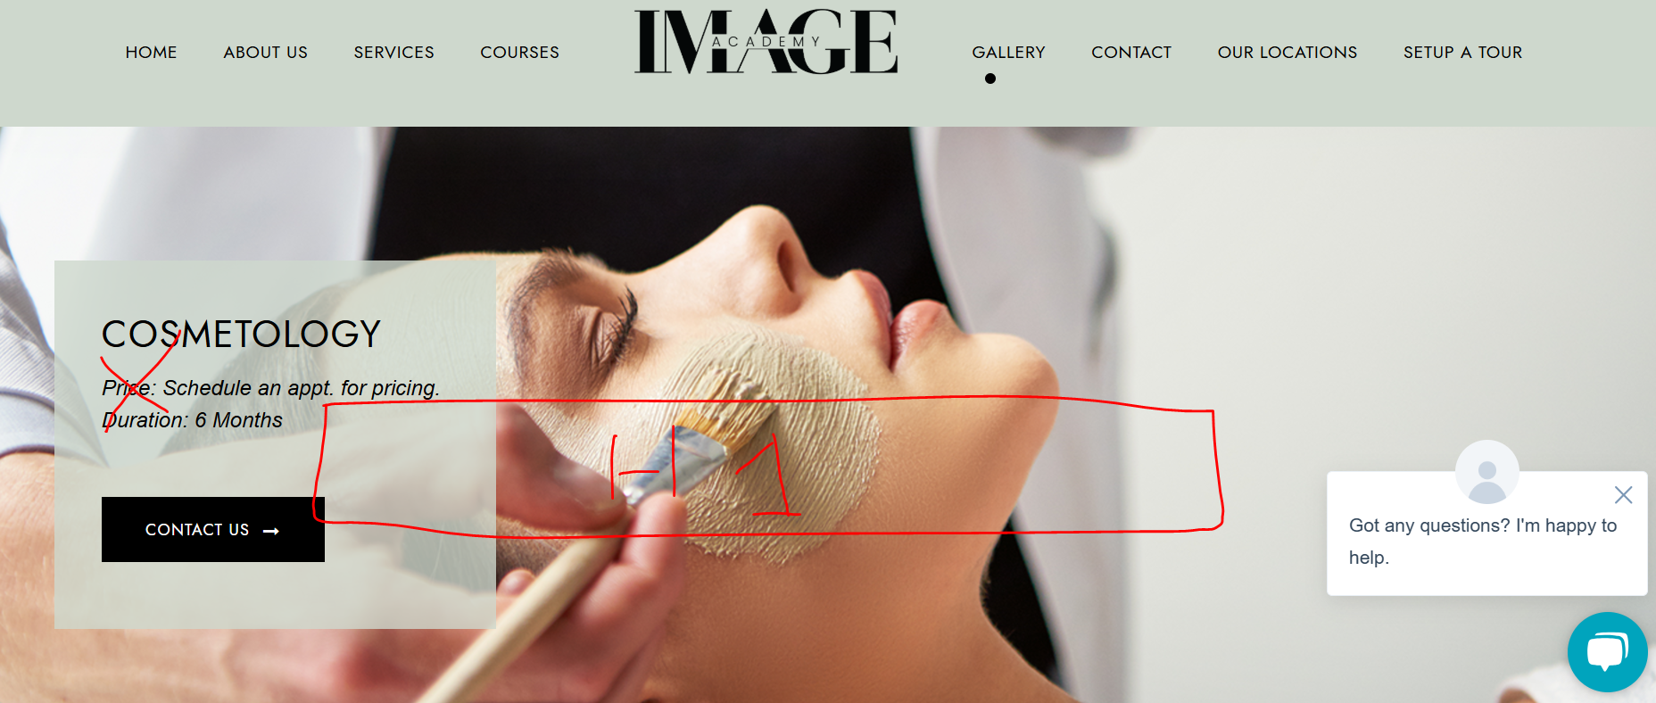

Esthetician School in Houston, TX (h1)
Become Master Estheticians at Image Academy in Houston.
Enroll Today

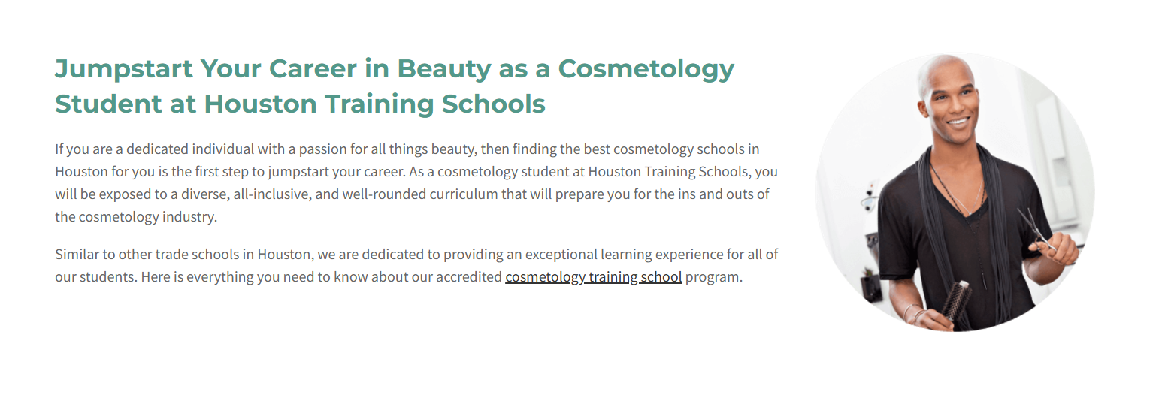

Transform Your Career With the Leading Esthetician School in Houston (h2)
Do you need help to launch or boost your career path in the esthetician sphere? And that’s where Image Academy comes in – the premier esthetician school in Houston. For the high-quality educational process, comfort, and facilities, practical work carried out by experienced professionals, our comprehensive programs will provide you with everything you need to feel successful in this rapidly developing area.
Our pleasure at Image Academy is to incubate future professionals in the skincare, makeup, and waxing industries. Our programs are therefore designed to offer modern trends, current methodologies, and skills so that you can meet standard market requirements in your chosen careers. Whether you are interested in foundation courses or energetic workshops, our esthetician certification program brings you the best and most practical solutions to help you succeed in the beauty world.
It’s your chance; apply today to master and start a successful aesthetician career at Image Academy, the best esthetic school in Houston. Turn the future to your advantage, and join our growing family of beauty specialists today!

Apply Now

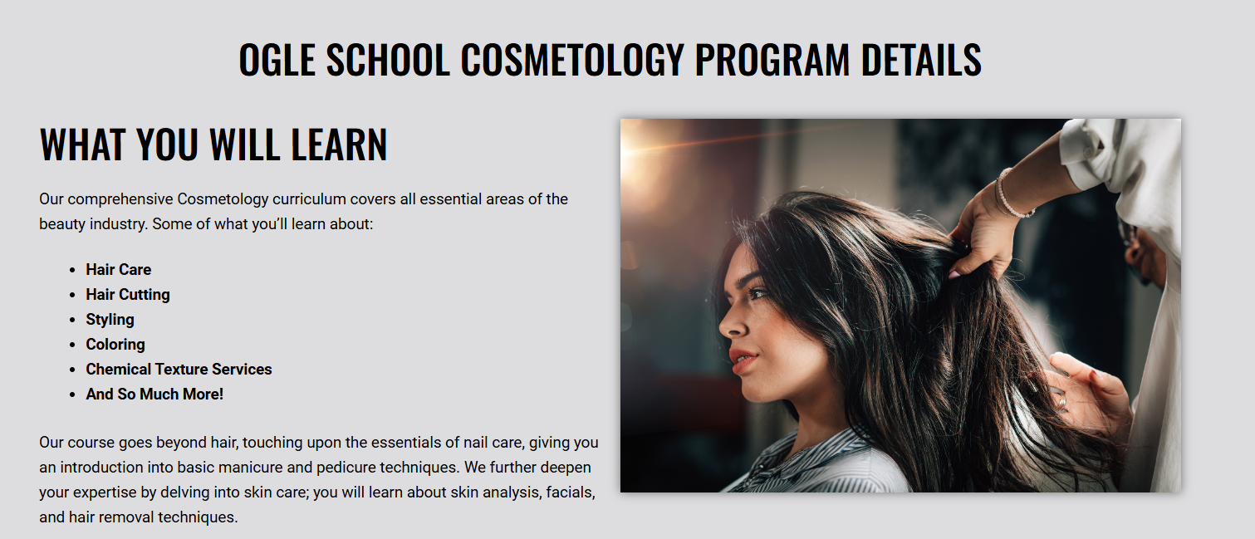

Image Academy Licensed Esthetician Course Detail (h2)

What Students Will Learn?
Read through the interesting opportunities that Image Academy offers in the sphere of Esthetics and join the school today. Our curriculum covers a wide range of topics, including:
- Skin Analysis & Consultation
- Facial Treatments
- Chemical Peels
- Microdermabrasion
- Waxing and Hair Removal
- Makeup Application
- LED Light Therapy
- Microneedling
- Dermaplaning
- Advance Chemical Peels
This is the best chance to become the best Esthetician you could ever be, so enroll in the Image Academy Esthetics program today!



Start Your Esthetician Journey Now (h2)
Welcome to the wide world of Esthetician opportunities with Image Academy! Come today to get started on your new and exciting life. Our comprehensive esthetics courses give you the details of our interesting course plan, which includes makeup, skincare, and aesthetics. With practice, you can enhance and learn various beauty techniques, and our beauty experts will surely turn you into a pro. Change lives, and yours too, with style and expertise, all capped in ability.

Request Information

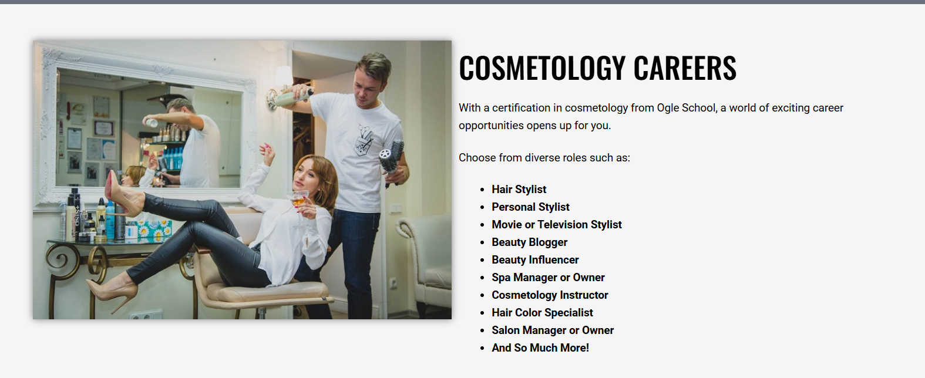

Esthetician Careers (h2)
An esthetician career at Image Academy comes with the promise of a world of endless opportunity for you. Choose from our diverse range of esthetician roles, such as:
- Beauty therapist in elegant spas
- Skin Care Educator or Trainer
- Fashion Esthetician
- Mobile Esthetician
- Skincare – Blogger or Influencer
- Spa Manager or Owner
- Self-employed Skin Care kit Advisor
- Skin Care Specialist for Movies and Television Productions
By the end of this program, you will be equipped for a great career in the esthetics field and prepared to change people’s lives through professional skin treatments.
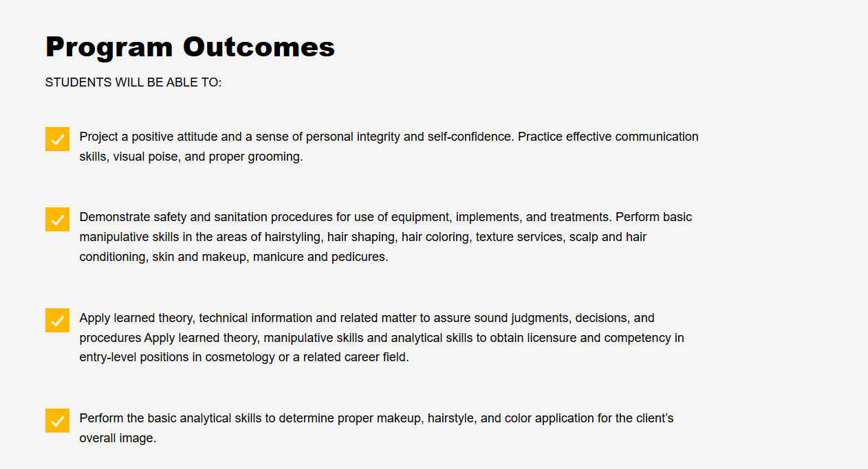

Outcomes of the Program (h2)
Students will be able to:
- After the program, the students will be able to acquire the necessary and relevant skills needed in the Esthetic world.
- Students will be able to understand types of skin and types of skin-related diseases and be able to perform deep cleaning, skin exfoliation, and facial masques for healthy glowing skin.
- Special lessons on makeup are included, including information about how to apply makeup to different skin types, ages, and occasions. Students will also learn how to apply makeup naturally and artistically and how to apply makeup for drama.
- Students will be taught different hair removal methods, such as waxing, threading, and sugaring.
- Students will hear about successful salon or spa management experiences, customer relations, appointments, and sales tips.

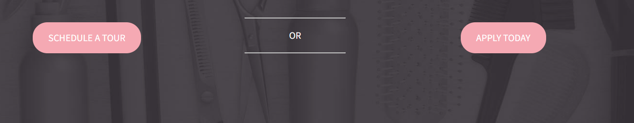

Become an Image Academy Esthetician Today (h2)

Do you wish to be part of the most appropriate Esthetician Program today? Welcome to Image Academy, the premier esthetician school near me in Houston. Enroll with us today to take the first step towards a rewarding esthetician career. Our Esthetician program provides thorough education where you can develop all needed skills and receive peculiar training.

Don’t waste any more time; enroll with us today and be on your way to becoming a professional Esthetician. To join our esthetician programs near me in Houston, apply through the website or visit the college at (281) 692-4892

Join us today | Start Your Career

About Your Instructor (h2)
Mrs. Skander (h3)
Mrs. Skander is a professional lady who can combine her teaching profession with her aesthetic talents. Originally from a beautiful country like Lebanon, Mrs. Skander is a knowledgeable and experienced worker in this field and has been an ESL teacher for more than six years. The loving wife and the happy mother of a beautiful, handsome boy, she has lots of life experience, making her a professional in teaching Aesthetics.

She enjoys teaching her students how to feel confident when dealing with clients. At Image Academy, Mrs. Skander is proud to be a part of it; she believes in cultivating the future of the beauty industry’s experts.

